|  |
| --- |
|  |
| Project  This Project is about Artificial Intelligence and its Applications. |
| |  |  |  | | --- | --- | --- | | Mohamed Adel | 4/6/21 | Computer Engineering | |



Shubra Faculty of Engineering, Banha University

*Name: Mohamed Adel Abdel-Monsef Salem*

*B.N: 6*

*Sec: 34*

*Topic: Artificial Intelligence*

*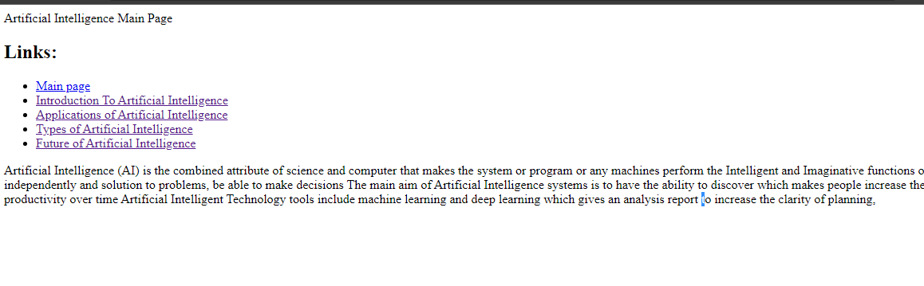****Screenshots:***

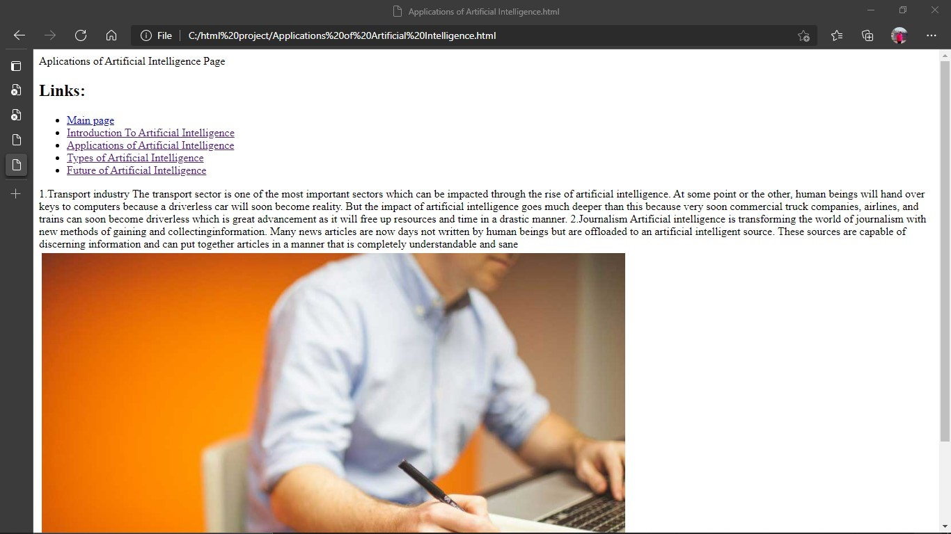

*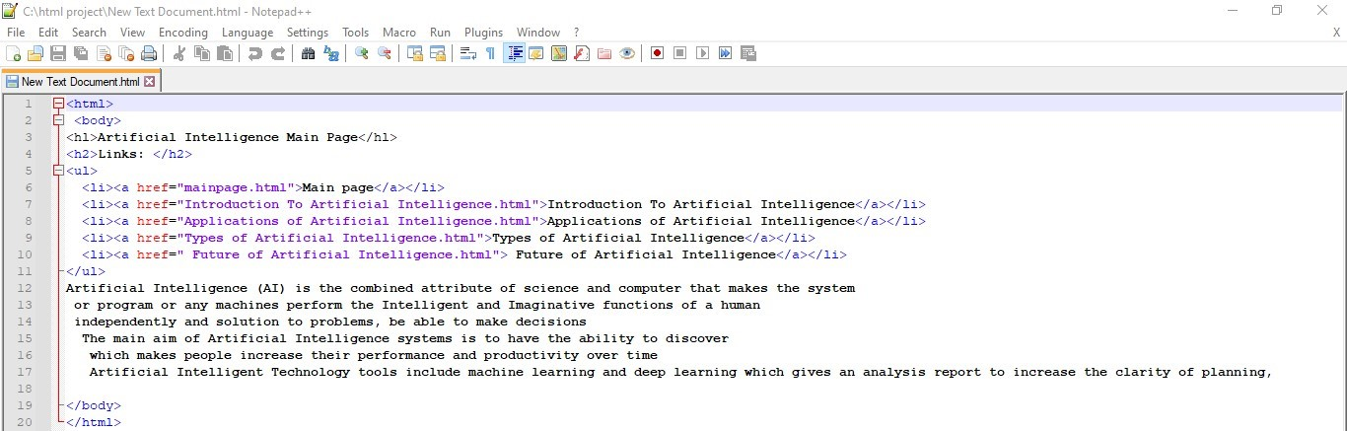****Source Code:***